Name ________________________________
Date ______________________
Term 5 Book Project
Word Cloud/Word Wall

You will need the following items for your word cloud/word wall:
- construction paper or poster board
- crayons, color pencils, markers, or chalk (glue and scissors if you are pasting the text)
- your word log

As you are reading your novel, write words that help describe the plot, theme, mood, or tone of your novel. You may use a mixture of words from each category. Use the “word log” to help organize your words or thoughts.

Your word wall/word cloud must include:
- 35 words that help describe your novel and your characters
(Do not use common words like “the,” “from,” “a,” etc.) Do not use the same word more than once.
To make your words stand out: alternate font style, size, and color.
- create a symbol that represents your novel
***A symbol is a person, place, object that stands for something beyond itself.
Example: = love
(Idea: Locate a theme of your novel and create an image – picture - that represents the theme .)
Option A: The symbol may be used as negative space. You will need to hand draw (outline) your symbol and place your words outside of the drawing to create the shape -- gives the illusion the words have created the symbol.

Example of negative space:
or
Option B: Create the symbol by using the words. You may need to outline the symbol and use the words to fill in the shape.

Examples:

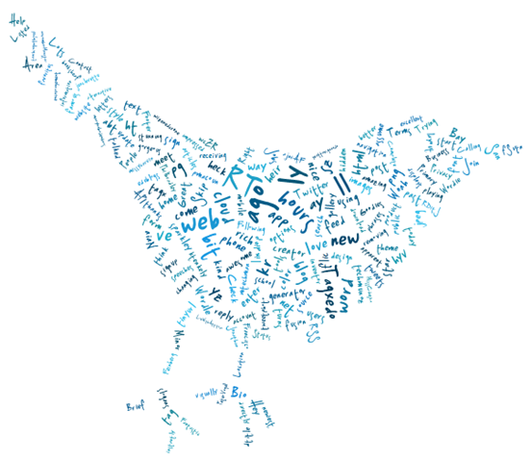

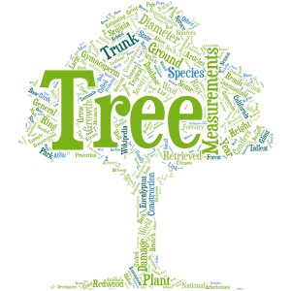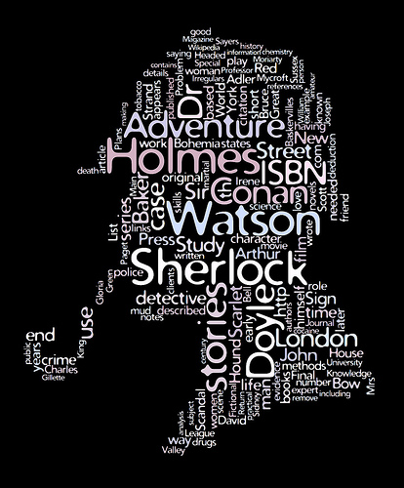

**This option may be easier to create.

