Directions For Accessing Our Science Books On-Line
- Open Google Chrome and go to www.thinkcentral.com
(Windows Explorer will work but with limited visibility and operation – not recommended.)
- Click on the green button “Science and Health”.
- Click on the white button “Science Fusion”.
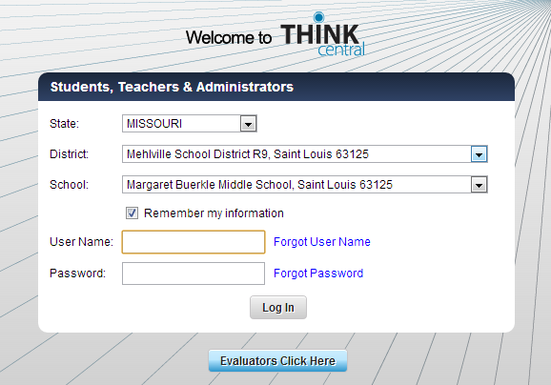
- Select the following
State: “Missouri”
District: “Mehlville School District
R9, Saint Louis 63125”
School: “Margaret Buerkle Middle
School, Saint Louis 63125”
- Check the box: “Remember my
information” (so that the above
items won’t have to be entered
again next time)
- Type your school ID under “User
name”
- Enter the password which is
“science1617” .
- Press “Log In”.
- Go to “My Library”.
- There are several buttons on this page. You will only need the four blue buttons that are
labeled “Science Fusion” and have one of the following titles:
- ScienceFusion Student Access English Module A Cells and Heredity
- ScienceFusion Student Access English Module B The Diversity of Living Things
- ScienceFusion Student Access English Module C The Human Body
- ScienceFusion Student Access English Module D Ecology and the Environment
- Click on one the above button for the textbook you want to access.
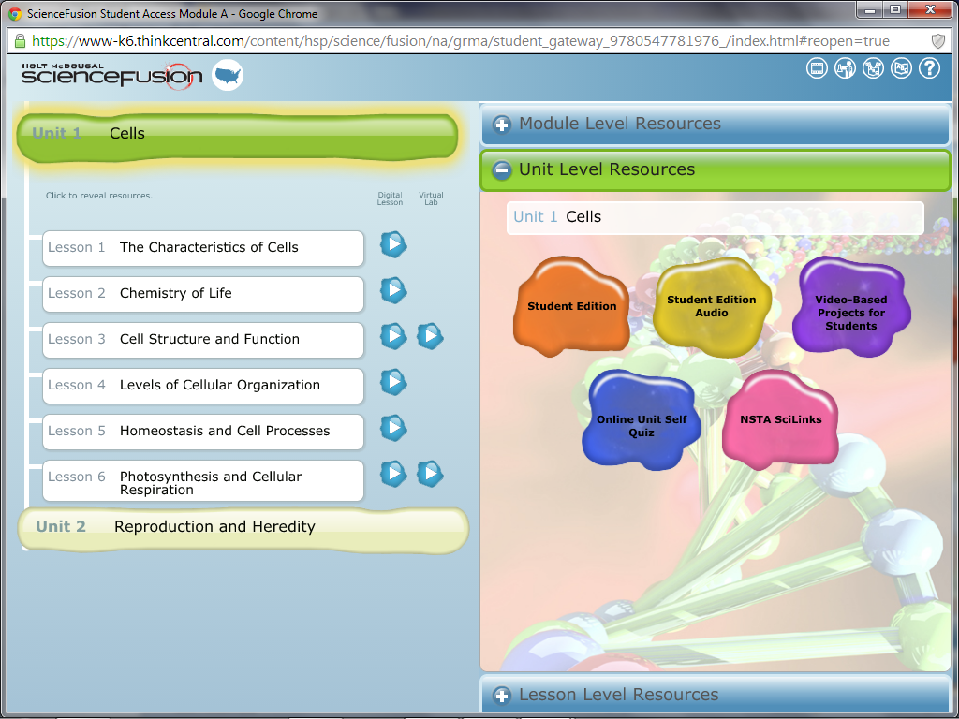
- Clicking on a selection will show the following screen: (the example below is for Module A).

- Clicking on either Unit will display each of the lessons contained in that unit, then click on the desired lesson.
- On the right of the page, click on “Student Edition” to open an electronic version of your book.
  - Select the “Page View” you prefer.
  - Move forward and backwards using the arrows to the right and left of each page.
  - The speaker icon in the upper left of each page will read that page aloud to you.
- Just to the right of each lesson’s title is a white arrow in a blue field. Clicking here will
play a “Digital Lesson” which covers the same information as the book but presents it
in a different manner. If you did not understand the lesson through reading the book,
this video may help you.
- Immediately to the right of these “Digital Lessons” sometimes is another white arrow that will play a “Virtual Lab”. These too can be played from home if you wish.

